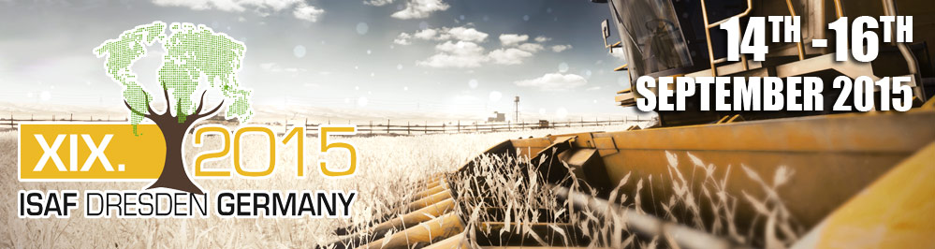

19th International Conference on Information Systems
for Agriculture and Forestry
ISAF 2015
14th – 16th September 2015 in Dresden, Germany
together with
Open Data Hackathon for Agriculture, Forestry, Environment, Tourism and Rural development and the Club of Ossiach Networking Event
Conference topics:
- Open Data for Agriculture, Forestry and Rural development
- Future Internet and Agriculture
- Precision farming and precision forestry issues
- ICT in Agriculture and Rural Development Research
- Sensors technologies
- ICT for Agriculture Sustainability
- Land use, Land cover and rural planning
- Farming on Cloud
- Space technologies for Agriculture, Forestry and Rural Development
- Environmental risk management
- Innovation and transfer of technologies
- International cooperation

All accepted papers will be published in a digital collection ISAF2015. Selected articles will be published on the website Agris On-line (Papers in Economics and Informatics journal), which is indexed in Scopus http://online.agris.cz.
Important dates for sending contributions:
- July 15, 2015 Submission of abstracts
July 25, 2015 Notification of acceptance of abstracts
5 September 2015 Submission full version of the paper
October 31, 2015 Notification of acceptance article
Conference registration ISAF 2015 preliminary program and further information, please visit http://www.isaf2015.info/
- Photos from last year's conference ISAF 2014
ISAF 2014 - Castle Jelgava, conference venue, photographer: Vojtech Lukas
ISAF 2014 - RNDr. Karel Charvát, photographer: Irena Košková
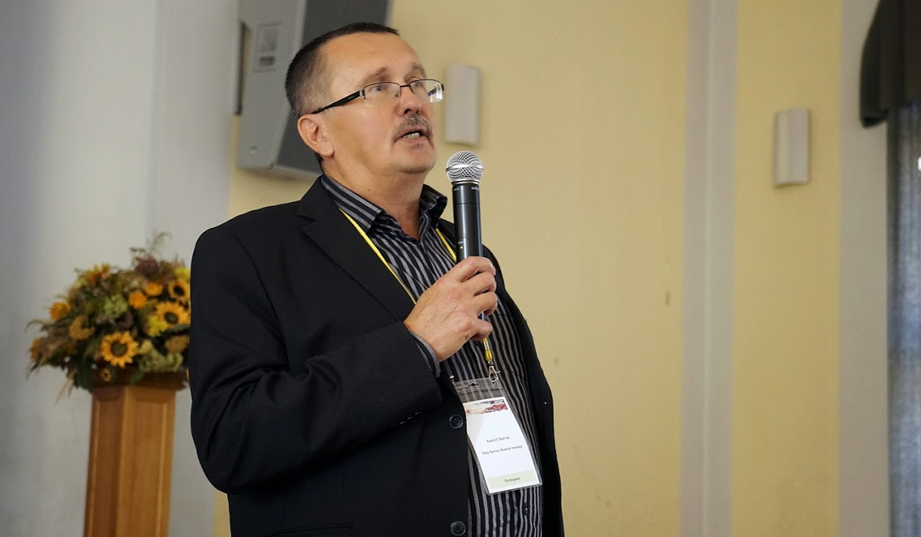
ISAF 2014 - the main conference, author photo: Sarka Horakova
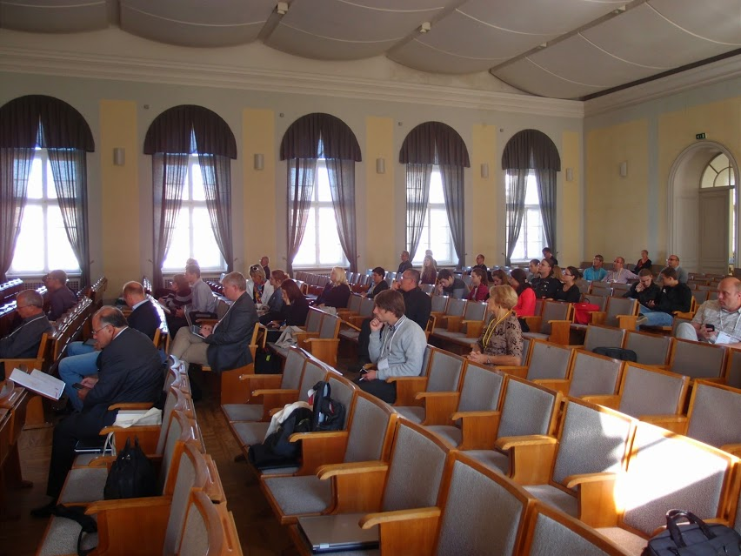

ISAF 2014 - Hackathon, author photos: Irena Košková
